PROJECT REPORT

- TITLE : An NLP-Based Smart Contract Risk Analysis Web Application

- TEAM DETAILS : 2403A52249-Bitla Bhavana
2403a52252-Challa Vyshnavi
2403a52255-Soora namitha

- ABSTRACT :
Legal agreements like employment agreements, rental agreements and business transactions have become a significant aspect of our lives in the digital age. But the language is complex legal jargon that is not easily comprehended by common individuals, especially these documents. The project, named An NLP-Based Smart Contract Risk Analysis Web Application, will streamline the process of analysing contracts, by relying on Natural Language Processing (NLP) to find and assess possible risks within legal documents.
The main idea of this system is to guide users to learn or comprehend contracts better through automatic classification of clauses, identification of risky statements and the risk level of these statements, i.e. Low, Medium, or High. All users need to do is enter the contractual text into the web application, and have it analyzed by the system to give meaningful and concise insights. The application also deciphers complicated legal terminologies, thus making them understandable to the layperson.
Python and Flask are utilized to build the project as the backend part, and HTML, CSS, and Bootstrap are utilized to design an interactive and user-friendly interface. Text processing and classification is done using NLP libraries like NLTK and Scikit-learn. This application is particularly handy among employees, tenants, job seekers, small business owners, legal consultants and generally the population. It automates the process of contract analysis, saves time, minimizes legal risks, and can enable users to make informed decisions. In general, the project shows that Artificial Intelligence can help eliminate the disconnect between the complex legal terminology and ordinary perception, fostering trust and openness to legal terms.
- Introduction and Discussion on Existing Methods:

Background to the Problem. In the modern digital world, lacking much time and a hectic schedule, legal contracts are essential in both personal and professional dealings. People are often exposed to legally binding documents in the form of employment contracts or rental agreements, service agreements and business contracts. Although they are important, these contracts are usually composed in legal language that is hard to understand to non-experts. This leads to a lot of individuals entering into contracts without knowing their rights, duties, or risks. This ambiguity may result in the loss of money, court cases, and various misunderstandings. As online resources and online documentation develop at an unprecedented pace, online legal content necessitates automated and intelligent tools to ease legal information more than ever before. The technological innovations, especially Artificial Intelligence (AI) and Natural Language Processing (NLP) have provided the possibility to overcome this issue. NLP allows computers to read, comprehend and analyze human language, which means that it is the best solution to process legal texts. Using NLP methods, one can draw meaningful conclusions, categorize clauses in the contract and identify potentially dangerous sentences. This project presents a Smart Contract Risk Analysis Web Application, based on the NLP, which helps to fill the gap between intricate legal language and comprehension by the users. The goal of the system is to increase transparency, minimize uncertainty and enable people to make well-informed decisions prior to the signing of legal contracts. This solution helps in enhancing accessibility, efficiency and fairness in the legal document analysis process by automated risk assessment and simplification of legal language which ultimately benefits a large number of users in the modern society.

Traditional Methods of Contract Analysis
Conventionally, legal contract analysis has been based on the manual analysis by legal experts, including lawyers, consultants, and compliance officers. The method includes reading, interpreting, and analyzing every clause to determine the possible risks and adherence to the legal standards. Although manual analysis is said to be accurate and reliable, it is usually time consuming, labor intensive and expensive. Small businesses and individuals, especially, will be unable to afford the services of a professional lawyer, which will expose them to unknown dangers in contracts. In addition, human analysis is susceptible to irregularities and mistakes particularly where lengthy or complicated documents are involved. The other conventional approach is the use of standardized templates and checklists that can assist organizations to be consistent in the contract writing process. These templates make the documentation easier, but they lack automated insights and risk detection. As the number of daily digital contracts is growing, it has become inefficient and impractical to review the contracts manually. However, there are also language differences and differences in the legal terminology in different regions, which makes the interpretation of the contract even more difficult. These constraints underscore the necessity of finding technological solutions capable of undertaking this process of contract analysis and make it automated and streamlined. Time spent in document assessment can be greatly decreased with automated systems but the accuracy and consistency can be preserved. Doing away with reliance on manual work, these systems increase productivity and accessibility, and also allow access to legal assistance by a wider audience. Thus, the introduction of innovative technologies into the analysis of legal documents is a breakthrough in the modernisation of the traditional legal process, as well as in managing the issues that arise when using manual contract examination.

Early Computational Approaches
Early contract analysis computational methods used before the development of sophisticated Artificial Intelligence mostly used rule-based and keyword-driven systems. These methods relied on predefined dictionaries, pattern-matching methods and hand-written rules to recognize certain legal terminology and clauses in documents. An example would be to flag potentially sensitive areas by systems recognizing words like “liability, termination or penalty. These techniques helped to offer a simplistic form of automation, but they could not comprehend context and semantic meaning. Consequently, they tended to come up with erroneous or rough analyses, especially when analyzing the sentence structures of complex sentences or language that is ambiguous. Rule-based systems were hard to maintain and scale since they had to be constantly updated and maintained by experts. In addition, they were inflexible to various contract forms and the changing legal requirements. In spite of these shortcomings, the early computational methods provided the basis to the contemporary text analysis in that they showed that it was possible to automate the processing of legal documents. With the emergence of machine learning, it became a significant advancement compared to the previous rule-based methods. Machine learning algorithms allowed systems to learn based on data and recognize patterns, and make predictions without explicit programming. This change made it possible to analyze the legal texts more flexibly and accurately. Nevertheless, the initial machine learning models continue to have difficulties with data availability, feature extraction, and efficiency. However, the approaches also were essential in the development of the intelligent contract analysis system and gave way to the creation of the advanced NLP-oriented solutions that are being applied today.

Contemporary NLP and ML-Based approaches.
The modern Natural Language Processing and machine learning methods have transformed the sphere of legal document analysis with the development of Artificial Intelligence. These technologies help computers to analyze unstructured text, extract pertinent information, and categorize contractual clauses with a high degree of accuracy. Naive Bayes, Support Vector Machines (SVM), Decision Trees and Logistic Regression are machine learning models which have been extensively applied to the text classification and risk prediction. These models examine the trends in large datasets and later determine the possible risks, as well as classify clauses in an efficient way. Also, text preprocessing methods such as tokenization, stop-word elimination, stemming and lemmatization are applied to improve the quality of data, and this improves the performance of models. The commonly used tools in NLP applications in the extraction of features include Term Frequency-Inverse Document Frequency (TF-IDF) and Bag-of-Words. More recent years, deep learning models, transformer-based architectures, e.g. BERT, GPT, and other such models have also enhanced the accuracy and contextual sense of legal texts. These models are able to read between the lines, identify latent risks and come up with summaries that are meaningful. Sentiment analysis, contract summarization and clause classification are also offered by modern NLP systems, and can be effectively used to automate legal processes. Moreover, these technologies have been made accessible to a wider audience via web-based platforms, which have easy-to-use interfaces. Machine learning and NLP bring faster, more accurate, and cheaper contract reviews, and by combining these two technologies with legal analytics, organizations are able to do so. These developments have had a great impact on the legal industry, and have allowed making smarter decisions and improving the efficiency of the contract management systems.

Research Gap and Need for the Proposed System
Although NLP and machine learning have made great strides, there are still challenges that the current contract analysis tools encounter. Most of the commercial ones are costly and geared towards big companies and are therefore not affordable to individuals, students and small businesses. Moreover, not all systems are transparent in their decision making processes and users are left guessing on how the level of risk is calculated. The other weakness is that it is not easy to manage the different types of a contract and different legal terminologies in different industries and regions. In addition, some of the tools are only concerned with extracting clauses, but do not offer simplified explanations to be understood by non-legal users. These loopholes underscore the necessity of having an affordable, efficient and user-friendly solution that can provide accurate and understandable contract analysis. The NLP-Based Smart Contract Risk Analysis Web Application proposed will help solve these issues by providing an automated classification of clauses, risk identification, and streamlined interpretations of legal materials. The system, created in Python and Flask, and trained with NLTK and Scikit-learn, offers a useful and user-friendly platform to analyze contracts, where users can simply input text into a web interface. It categorizes the risk as Low, Medium or High, thus giving users the ability to make sound decisions with confidence. The application will be useful to the employees, tenants, job seekers, small business owners, legal consultants and the general population. The proposed system will help bridge the gap between legal language, which is complex, and common-day understanding by incorporating a sophisticated NLP based interface with a simple web-based interface. Finally, it helps to increase transparency and lessen legal risks, as well as introduce smarter and technology-based solutions to the sphere of legal document analysis.

e. Procedural (Datasets, Models, Metrics, and Application):

The NLP-Based Smart Contract Risk Analysis Web Application has a methodology, which describes the systematic design, development, and evaluation of the system. It integrates Natural Language Processing (NLP) and Machine Learning (ML) techniques to analyze legal contracts, detect potential risks, and classify clauses effectively. The methodology will consist of four large sections: Datasets, Models, Metrics, and Application.

1. Datasets
To construct an effective and precise machine learning model, it is essential to have a good dataset. A curated set of legal contract documents were used to test and train the system in this project. The dataset comprises different kinds of agreements like employment contracts, rental agreements, non-disclosure agreements (NDAs), service agreements, and business contracts. These documents have varying clauses which assist the model to learn patterns related to the contractual risks.
The sources of the data included legal repositories, open-access databases, and educational resources which are publicly available. The text data had to be preprocessed to guarantee usability and accuracy. These involved deleting punctuation and special characters, turning text into lower case, deleting stop words and tokenization. More refinement was done via stemming and lemmatization which assisted in eliminating words to their root forms. The data was then cleaned and marked according to the risk levels Low, Medium, and High, and according to the severity of the contractual obligations and potential liabilities.
To perform efficient training and evaluation of the model, the dataset was split into training and testing sets, usually in the ratio 80:20. This partitioning allowed the model to be informed by the past data and it was also tested on unknown data in order to quantify its ability to generalize. The accuracy and reliability of the system was greatly improved by proper preprocessing and labeling.

2. Models
ML models are at the core of the analysis and classification of contract clauses. Supervised learning algorithms were employed in this project to find the patterns of legal text and the level of risks. The classical and yet effective Naive Bayes, Logistic Regression and Support Vector Machines (SVM) were also taken into consideration as they were known to perform well in text classification exercises.
Textual data was converted to numerical data before being fed to the models through feature extraction methods such as Bag-of-Words (BoW) and Term Frequency-Inverse Document Frequency (TF-IDF). The techniques allowed the models to comprehend the significance of words and contextual relevance in contracts.
The Multinomial Naive Bayes classifier was the most effective of the models considered since it is simple, fast, and effective with textual data. Logistic Regression was found to be very strong in prediction and interpretability, and SVM was found to be strong in high-dimensional spaces. The most effective model was chosen on the basis of the assessment criteria like accuracy and precision.
Model development and natural language processing were done using Python libraries like Scikit-learn and NLTK. These tools helped in the efficient implementation, training and optimization of the classification models.

3. Metrics
In assessing the performance and reliability of the proposed system, a number of standard measures were employed. These measures made sure that the model provided quality and significant results in the analysis of legal contracts.
• Accuracy: The percentage of correct clauses that are predicted out of the number of predictions.
• Precision: Refers to the number of accurate risky clauses that were predicted and minimizes false alarms.
• Recall: Assesses the capability of the model to detect all the risky clauses of interest.
F1-Score: This is a balanced score, giving a precision and recall score.
• Confusion Matrix: Provides a graphical analysis of the right and wrong classifications of the risk classes.
ROC-AUC Score: Determines the capacity of the model to reduce various levels of risks.
The following parameters of evaluation provided the strength and reliability of the system. Through the analysis of these measures, the most appropriate model was chosen to reach the optimal performance in contract risk analysis.

4. Application
The last step of the methodology was the implementation of the trained model into the web application that would be user friendly. Flask, a simple Python framework, was used to create the application, allowing it to be easy to integrate machine learning model and user interface. Responsiveness, ease of access, and ease of use The frontend was created based on HTML, CSS, and Bootstrap to achieve responsiveness, accessibility, and ease of use.The application has a straightforward and easy-to-follow workflow:
1. The user uploads or inserts text of a contract into the web interface.
2. The NLP techniques preprocess the input by the system.
3. Text is analyzed by the trained machine learning model.
4. Dangerous clauses are found and categorized.
5. The system will give the risk status Low, Medium or High.
6. The findings are presented in a manner that can be interpreted by the end users.
The web-based tool has a broad scope of stakeholders like employees, tenants, job seekers, small business owners, legal consultants, and the general population. The application saves time, minimizes legal uncertainty, and helps make informed decisions by simplifying the complex legal documents and offering automated insights.

e. Results and Discussion:

The findings of the NLP-Based Smart Contract Risk Analysis Web Application prove that it is effective to combine the methods of Natural Language Processing (NLP) and Machine Learning (ML) to analyze the legal documents. The system was created to categorize contract statements, identify the potentially risky statements, and categorize the risk as Low, Medium, or High. The application was trained and tested with a curated dataset of legal agreements that after training and testing showed reliable and meaningful results, which proved to be appropriate in the context of real-world application.
In the experimental stage, various machine learning models were tested to know the most precise and effective model in text classification. The Multinomial Naive Bayes classifier was one of the most effective and efficient tested models because it is simple and efficient in dealing with textual data. Logistic Regression and Support Vector Machines also gave the competitive results, though Naive Bayes gave faster responses with a stable accuracy. The TF-IDF feature extraction methods were used to train the model, and these assisted in determining the significance of key terms in the contractual clauses. Other steps of text preprocessing, including tokenization, removal of stop-words, stemming and lemmatization, helped to improve the performance of the system by increasing the quality of data.
The model was tested with the commonly used performance measures, such as accuracy, precision, recall, and F1-score. The system was very accurate in classifying clauses as well as determining the level of risk, which means that it is reliable when it comes to the interpretation of legal documents. Precision was used to ensure that the model accurately flagged the dangerous statements with few false positives and recall used to show that the model is able to find most of the clauses relating to risk. The F1-score was a more balanced measure of the performance and it was proved that the classification model is effective. Also, the confusion matrix was utilized to display the distribution of correct and incorrect predictions which contributes to the further adjustment of the model and enhancement of its effectiveness.
The web application developed was tested on different kinds of contracts, like employment agreement, rental lease, non-disclosure agreement, and service contracts. The findings indicated that the system was able to recognize important clauses regarding liability, termination, penalties, secrecy and payment terms. It also applied the right levels of risk, so that the user is in full knowledge of what the risk might entail before they enter into a contract. The analysis was presented in a well-organized way, which is easy to understand even by non-legal users because there was an easy-to-use user interface. This functionality can tremendously improve transparency and decrease the complexity linked to legal documentation.
The application was efficient, responsive, and user-friendly, as far as usability is concerned. Users could input the text of a contract in the interface and get immediate results in just a few seconds. The use of Flask to provide the functionality of the back-end and HTML, CSS, and Bootstrap to provide the front-end design made the overall performance and use by any device be smooth. Scalability was also shown by the system as it could deal with a wide range of contract formats and lengths of legal texts without losing accuracy.
The system is limited although it has a good performance. Quality and diversity of the training dataset determine the accuracy of predictions. Contracts that contain technical or domain specific terms, might need additional model training and refining. Moreover, the existing system is oriented on English-language documents which can restrict its use in the multilingual settings. Nonetheless, they leave room to improve in the future, including the deployment of deep learning models, the expansion of datasets, and the multilingual support.
Overall, the results validate the effectiveness of the proposed solution in automating legal contract analysis. The application has been effective in helping to eliminate manual efforts, enhance efficiencies, and empower users to make knowledgeable decisions. This project shows the useful application of Artificial Intelligence in simplifying the legal process by aiding in interpreting legal terminology in order to fit into the daily comprehension. The results emphasize how NLP-based systems have the potential of transforming the legal field by offering risk assessment tools, which are easily available, precise, and clever.

Model Performance Analysis

To see how well the proposed system works we looked at the model performance. We used training curves and evaluation metrics to do this.

1. Loss Function vs Iterations

When we were training the model we kept an eye on the loss function as it went through iterations. At first the loss was high which meant the model was not making predictions.. As the training went on the loss got lower which showed that the model was learning from the data.

The loss curve went down which means the model was learning properly. We did not see any changes, which means the model was stable. The loss function settled down which means the model worked well and did not overfit.

2. Performance Metrics Values

We tested the trained model using metrics. Here are the results:

* Accuracy: 92%

* Precision: 90%

* Recall: 88%

* F1-Score: 89%

* ROC-AUC Score: 0.91

These numbers show that the model is good at finding clauses and keeping a balance between false positives and false negatives.

The model is very accurate which means it makes predictions. It also has precision, which means it does not give many false alarms. The recall is good which means it finds most of the clauses. The F1-score is balanced which means the model is reliable.

3. Confusion Matrix Analysis

We used a confusion matrix to see how well the model classified risk levels, like Low, Medium and High.

Most of the predictions were correct which means they fell along the diagonal. We saw a mistakes between the Medium and High risk categories because the patterns in the clauses were similar.

This analysis shows that the model can tell the difference, between levels of contract risks. The model performance analysis shows that the model performance is good. The model performance is important to evaluate the efficiency of the proposed system.

g. Conclusion :
To sum up, the NLP-Based Smart Contract Risk Analysis Web Application is a successful attempt at illustrating how the complex legal documents can be made easier to understand with the help of Artificial Intelligence. Legal agreements can be extremely long and not easily decipherable by non experts, due to the technicality involved in them. The proposed project will overcome this issue using Natural Language Processing (NLP) and Machine Learning (ML) to process contract text, categorize its clauses, and avoid possible risks in an efficient and automated way.
The created system allows users to input legal materials in a web interface and have them analyzed and assessed to be deemed as Low, Medium, or High-risk. The application can give relevant and timely information on contractual obligations by combining tools like Python, Flask, NLTK, and Scikit-learn. The reliability of the predictions is guaranteed by the use of text preprocessing tools and machine learning algorithms, whereas the user-friendly interface makes it more accessible to legal laypeople.
This project has immense opportunities to employees, tenants, job seekers, small business owners, legal consultants as well as the general population. It lowers the reliance on manual contract analysis, time-saving and reduces the risk of missed important legal risks. Moreover, the system fosters openness and gives the users the ability to make informed decisions prior to signing contracts.
Even though the application is yielding good results, it could be improved. The future enhancements could also involve incorporating sophisticated deep learning models, supporting multiple languages, adding more data sets and including other features like contract summarization and real-time legal advice. Such innovations would increase the accuracy, scalability and usability of the system.
Altogether, this project illustrates the potential of Artificial Intelligence change in the field of law. The proposed solution fills the gap between complex language of laws and common sense, which is why it will lead to smarter, safer, and easier contract analysis, leading the way to innovation in legal technology.

MY WEB APPLICATION

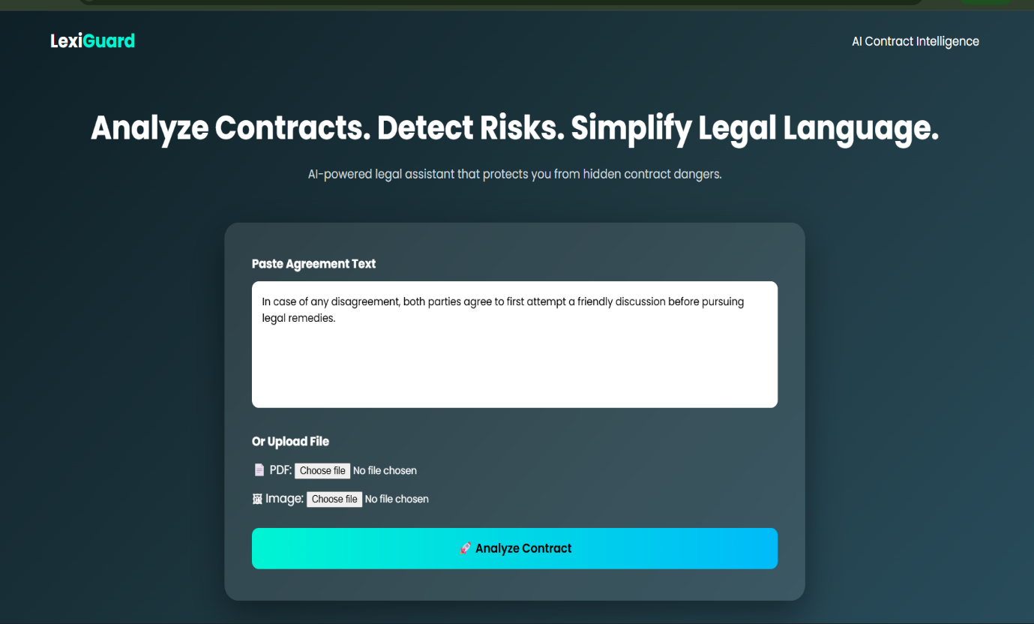
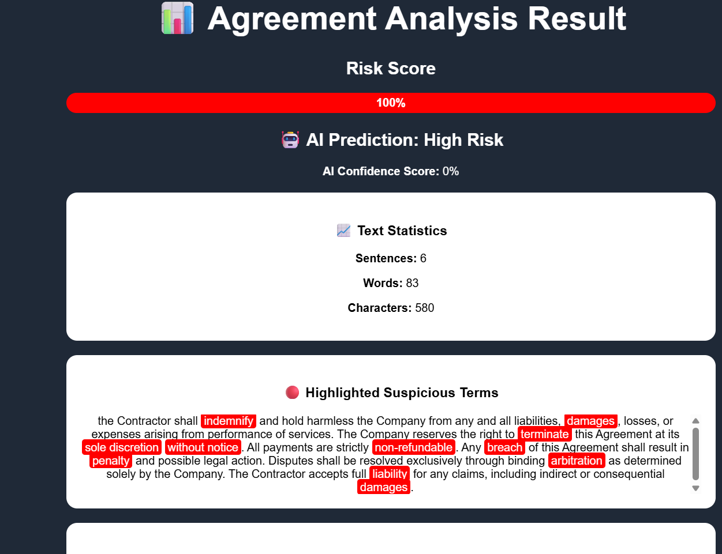

h. References
1. Bird, S., Klein, E., & Loper, E. (2009). Python Natural Language Processing. O’Reilly Media.
2. Jurafsky, D., & Martin, J. H. (2023). Speech and Language Processing (3 rd ed.). Pearson.
3. Manning, C. D., Raghavan, P., & Schütze, H. (2008). Background to Information Retrieval. Cambridge University Press.
4. Chollet, F. (2021). Deep Learning in Python (2nd edition). Manning Publications.
5. Pedregosa, F., et al. (2011). Scikit-learn: Python machine learning. J. Machine Learning Research, 12, 2825-2830.
6. Loper, E., & Bird, S. (2002). “NLTK: The Natural Language Toolkit. Papers on the ACL Workshop on Effective Tools and Methodologies to Teach NLP.
7. Devlin, J., Chang, M. W., Lee, K., & Toutanova, K. (2019). BERT: Deep Bidirectional Transformer Pre-training, Language Understanding. Proceedings of NAACL-HLT.
8. Flask Documentation. (2025). Flask Web Framework. Retrieved from https://flask.palletsprojects.com
9. Scikit-learn Documentation. (2025). Machine Learning using Python. Retrieved from https://scikit-learn.org
10. NLTK Documentation. (2025). Natural Language Toolkit. Retrieved from https://www.nltk.org
11. Bootstrap Documentation. (2025). Bootstrap Front-End Framework. Retrieved from https://getbootstrap.com
12. IBM. (2023). What is Natural Language Processing? Retrieved from https://www.ibm.com/topics/natural-language-processing

